**Employee Management System - SQL Exercises**

**Exercise 1: Create a Scalar Function.**

**Goal: Create a scalar function to calculate the annual salary of an employee.**

**SOLUTION :  
Use the Correct Database**

USE EmployeeDB;

GO

**Create the Scalar Function**

CREATE FUNCTION fn_CalculateAnnualSalary (

@MonthlySalary DECIMAL(10,2)

)

RETURNS DECIMAL(10,2)

AS

BEGIN

RETURN @MonthlySalary * 12;

END;

GO

**Test the Function**

SELECT

EmployeeID,

FirstName,

LastName,

Salary AS MonthlySalary,

dbo.fn_CalculateAnnualSalary(Salary) AS AnnualSalary

FROM Employees;

**OUTPUT :**

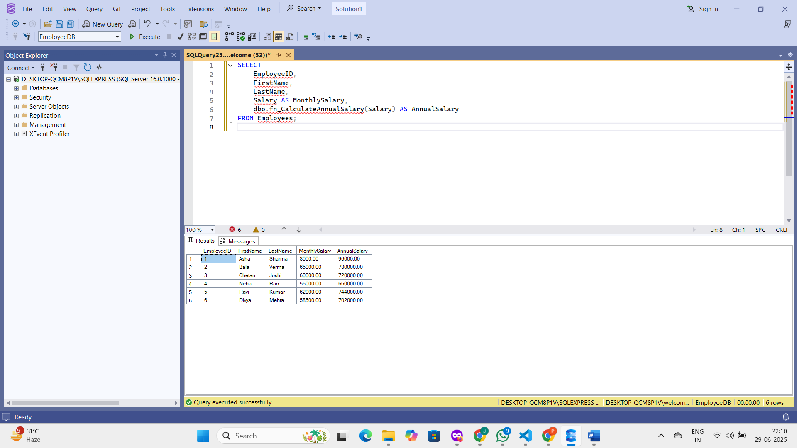

**Exercise 7: Return Data from a Scalar Function.**

**Goal: Return the annual salary for a specific employee using `fn_CalculateAnnualSalary.**

**SOLUTION :  
Use the Correct Database**

USE EmployeeDB;

GO

**Execute the Function for EmployeeID = 1**

SELECT

EmployeeID,

FirstName,

LastName,

Salary AS MonthlySalary,

dbo.fn_CalculateAnnualSalary(Salary) AS AnnualSalary

FROM Employees

WHERE EmployeeID = 1;

**OUTPUT :**